Pregnant women with gestational diabetes mellitus exhibit unique features in oral microbiome
Running title: Classification of gestation diabetes mellitus with oral microbiota
Xiaoqing Li ^{1, †}, Jiayong Zheng ^{1, †}, Xiuling Ma ^{2, 3, †}, Bing Zhang ^{2, 3}, Jinyang Zhang ^{2, 3}, Wenhuan Wang ¹, Congcong Sun ¹, Yeping Wang ¹, Jianqiong Zheng ¹, Haiying Chen ¹, Jiejing Tao ¹, Hai Wang ¹, Fengyi Zhang ^{2,3}, Jinfeng Wang ^{2, 3, *}, Hongping Zhang ^{1, *}
¹ Wenzhou People's Hospital/Wenzhou Maternal and Child Health Care Hospital/The Third Clinical Institute Affiliated to Wenzhou Medical University, Wenzhou, Zhejiang 325000, China
² Computational Genomics Lab, Beijing Institutes of Life Science, Chinese Academy of Sciences, Beijing 100101, China

³ University of Chinese Academy of Sciences, Beijing, China

* Corresponding authors:
Jinfeng Wang, No. 1 Beichenxi Road, Chaoyang District, Beijing 100101, China (address), 86-10-84504372 (telephone), 86-10-84504120 (fax), wangjf@biols.ac.cn (email).
Hongping Zhang, No. 57 Canghou Street, Lucheng District, Wenzhou 325000, China (address), 86-577-88059910 (telephone), 86-0577-88059502 (fax), zjzhp@126.com (email).
† Xiaoqing Li, Jiayong Zheng and Xiuling Ma contributed equally to this work.

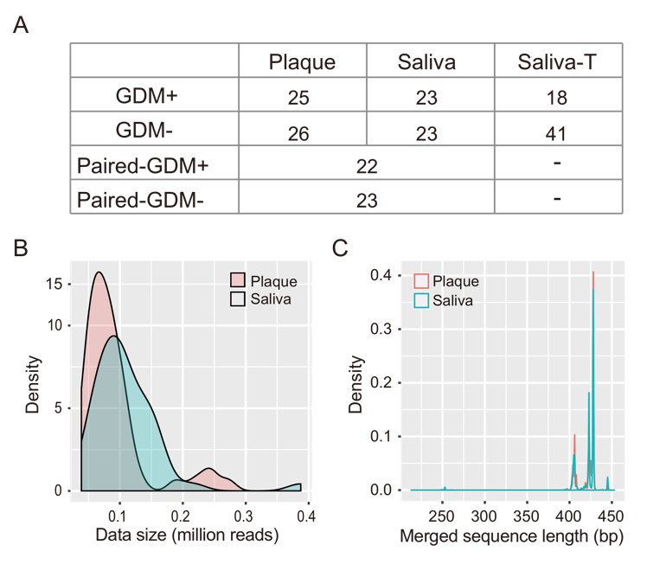
Additional file 1. Number of the samples and data size of 16S rRNA gene sequencing in this study. A. Number of saliva and dental plaque samples collected in this study. Among them, paired-GDM+ and paired-GDM- were paired saliva and dental plaque samples collected from the same subject, and saliva and saliva-T were unpaired salivary samples used to build ROC curves. B. Sequencing depth of the samples in this study. C. Sequence length distribution after PE-reads merging based on overlaps.

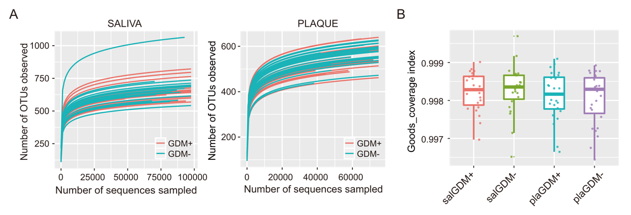
Additional file 2. Coverage of sequencing data. A. Rarefraction curves of the number of OTUs observed in saliva and dental plaque samples. B. Goods_coverage index of saliva and dental plaque samples.

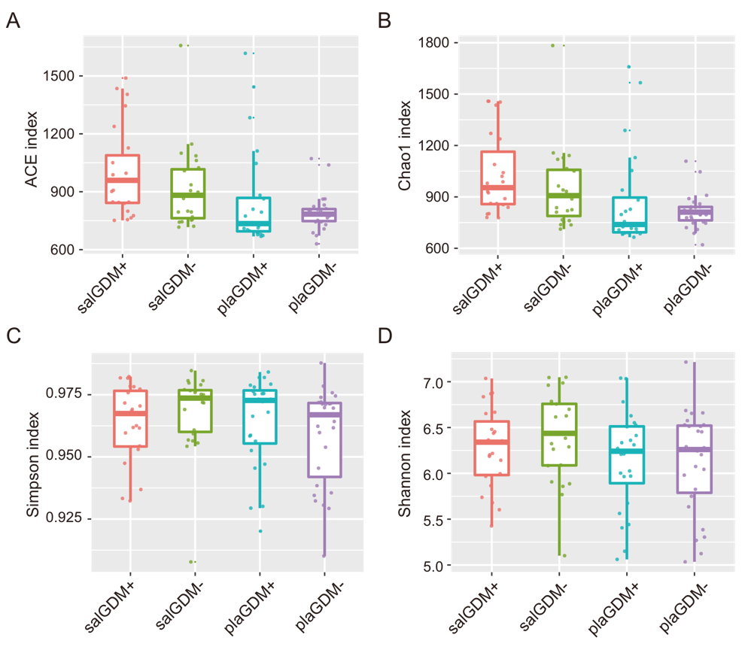
Additional file 3. Comparison of α-diversity between GDM+ and GDM- groups in saliva and dental plaque. A. ACE index B. Chao1 index C. Simpson index D. Shannon index.

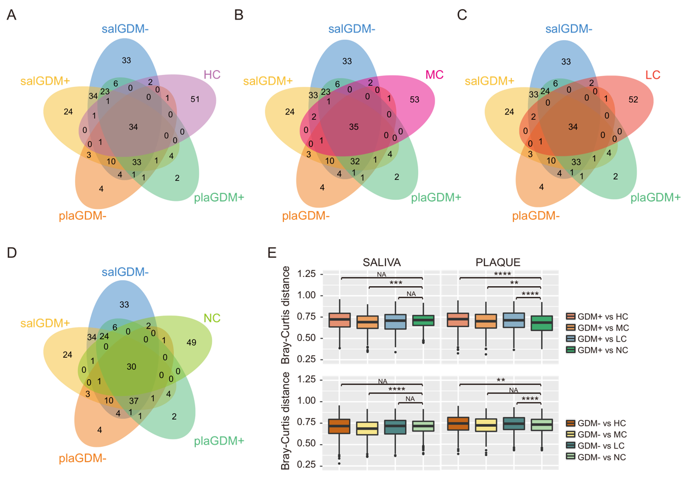
Additional file 4. The similarities and differences of oral microbiota between dental caries and GDM. A. Number of shared bacterial genera between HC and GDM. B. Number of shared bacterial genera between MC and GDM. C. Number of shared bacterial genera between LC and GDM. D. Number of shared bacterial genera between NC and GDM. E. Bray-Curtis distances between oral microbiota of patients with different degrees of dental caries and pregnant women with GDM. NC, LC, MC, and HC represent non, low, medium, and highly dental caries, respectively. * denotes P < 0.05; ** denotes P < 0.01; and *** denotes P < 0.001.

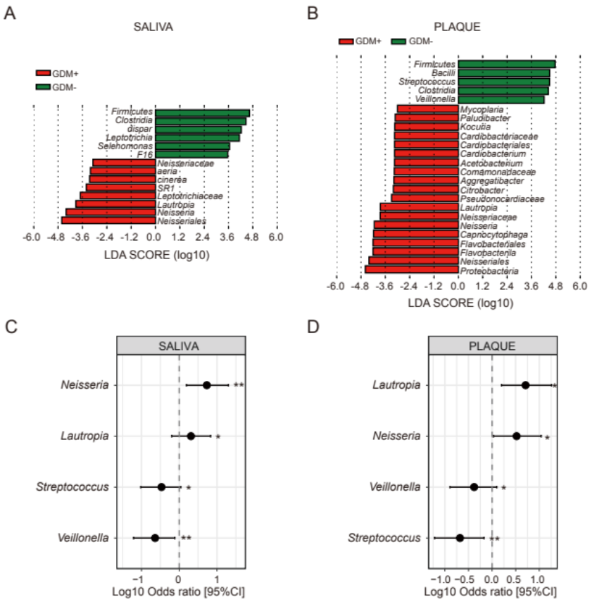
Additional file 5. Bacterial biomarkers of GDM+ and GDM-. LDA scores of bacterial biomarkers down to genus level in saliva and plaque were calculated by using LEFSe. Colour indicates the group in which a differentially abundant taxon is enriched (red: GDM+, green: GDM-). C-D. Four genera with the highest GDM+/GDM- ratio. * denotes P < 0.05, ** denotes P < 0.01.

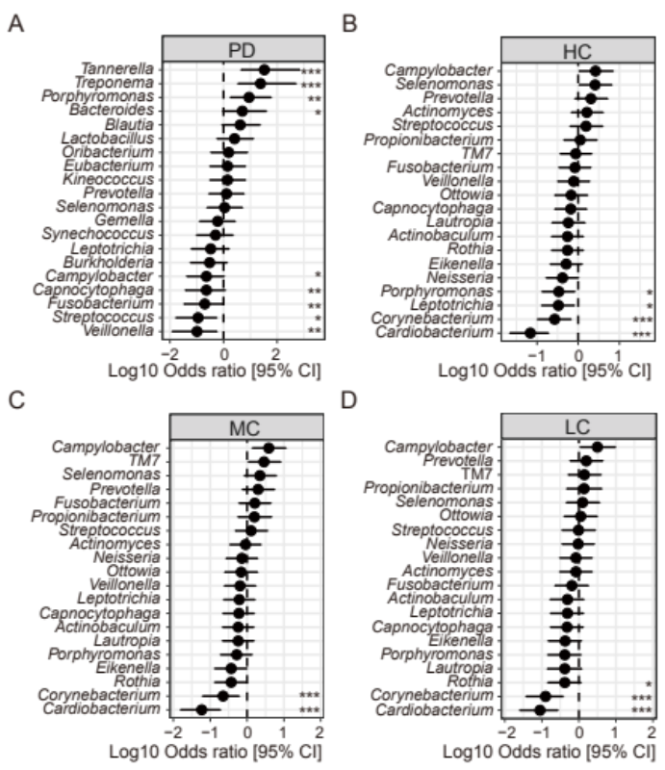
Additional file 6. The differences in periodontitis or dental caries compared to healthy controls. A. Twenty genera with the highest PD/PH ratio. B. Twenty genera with the highest HC/NC ratio. C. Twenty genera with the highest MC/NC ratio. D. Twenty genera with the highest LC/NC ratio. * denotes P < 0.05, ** denotes P < 0.01, *** denotes P < 0.001.

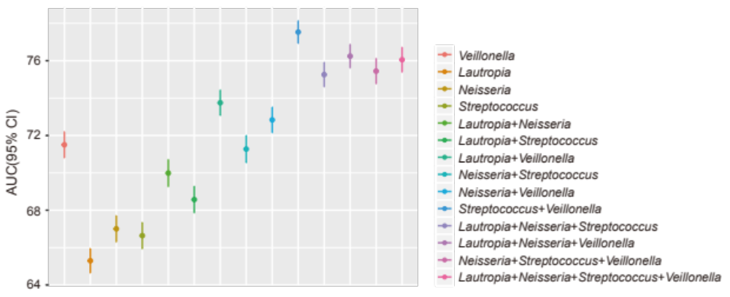
Additional file 7. Orthogonal results of 100 iterations of four genera combinations in saliva samples (n = 45).

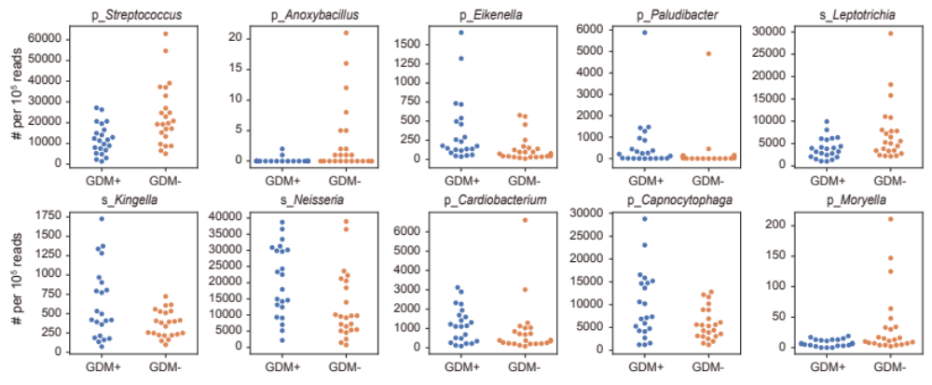
Additional file 8. The relative abundance of the top 10 most important genera for differentiation GDM from healthy pregnant women. Genus abundance in each sample was normalized to 100,000 reads. p_ represents microbes from dental bacteria and s_ represents microbes from saliva.

